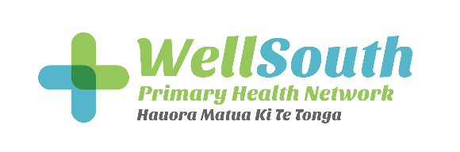

What the report says: Evaluation of the Tōku Oranga (Access and Choice) Programme
WellSouth commissioned Synergia to conduct an independent evaluation of the Tōku Oranga-Access and Choice programme, evaluating the programme’s implementation in Southern so far with the aim of informing the continued implementation of the programme at practices and providers in Otago and Southland.
Among Synergia’s findings:
- Tōku Oranga-Access and Choice responds to a much broader range of biopsychosocial needs than counselling. This model has been designed to be available for people of all ages with any concern they may have; be it mental health, physical health, or social health with a particular focus on behaviour change strategies.
- Offers consumers fast access to effective support.
- Has meaningful and measurable benefits; there’s evidence of the programme’s effectiveness. Each session is started with a questionnaire that aims to understand the persons health related quality of life. When people return, it is repeated to track progress and celebrate wins- big or small.
- Tōku Oranga-Access and Choice approaches are centred around goals and actions. The programme aims to be client centred with particular interest in a person’s strengths and values.
- The approach is more flexible and practical than counselling.
- Referrals to the Brief Intervention Service (BIS) – a brief counselling service – dropped by a statistically significant 39% in the 13 sample practices evaluated.
- Referral rates to secondary mental health services showed a small (insignificant) reduction … which may indicate the programme is reaching the missing middle and not simply substituting primary care for secondary mental health support.
- Consumers had high degrees of activation and began the journey with an attitude of being willing to try anything.
- Consumers have a sense of accountability towards their worker, which played a key role in activation.
- The achievements of this programme are to be celebrated. The impact the programme is having on the lives of consumers is huge, and one that cannot be communicated by routinely generated programme data.
For Māori
- Improvement in well-being was equitable. And Māori do not have notably different patterns of use, role associations or helpfulness, compared to non-Māori
- 85% of consumers were very confident in carrying out their plan from their consultation.
Recommendations for futures improvements:
- Better promotion of the programme generally and within practices.
- Additional qualitative enquiry using kaupapa Māori paradigm recommended, to fully understand how, where and why Tōku Oranga is or isn’t experienced as equitable by Māori.
- Explore further the predominance of single consults. Indicator of poor fit or immediate, effective support?
- Aim to improve and expand introductions ensuring consumers/patients are introduced to the right role for their needs – rather than mostly the initial introduction to the HIPs (Health Improvement Practitioners).

