FAQs for practices, created 20 January, updated 9 Feb.
ABOUT NOTIFICATIONS AND SPECIALIST LETTERS
- Which patients were compromised?
In the South Island there were approx. 2634 individuals impacted. This data was provided by HNZ based one NES match from MMH data.
PHOs received a list of the number of people impacted broken down by region and by practice – this list was provided by HNZ based on information they received from MMH. Practices also received a list and link to the MMH platform - Secure Provider Portal – Reports to reports to view the data.
- Why is MMH taking responsibility for notifying patients?
MMH are responsible for making direct contact with the affected consumers aligned to the privacy act expectations. PHOs note that even with best effort some people’s contact details and situation will not be verifiable as impacted due to inaccuracies in the records.
Updated 9 Feb: While MMH is still notifying patients, practices can now notify patients too. See legal advice and other below.
- How can I see who has been impacted?
Practices can check their impacted patients by accessing report 20 in the Provider Portal or refer to the reports that have been shared with them confidentially. Patients who have numbers provided in the Northland and Patient upload columns have been affected. Please note that the specialist referrals documents were not accessed, so no one in that column was affected (unless they also had documents in the other categories).
Updated 9 Feb: MMH are also emailing practices.

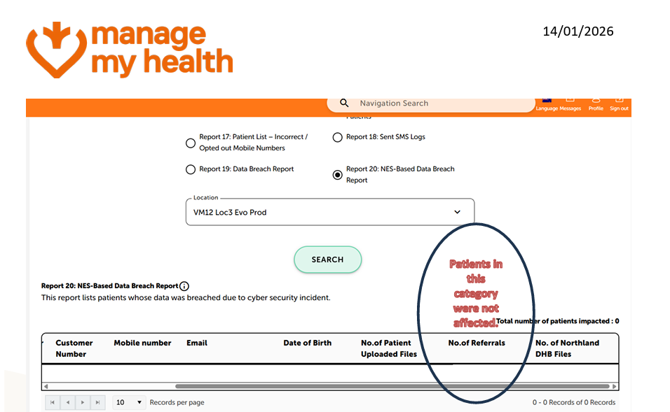

- Which report is the right one?
Report 20 as it includes any patients from Northland who may have enrolled with you.
- MMH said that specialist referrals were also affected, but in the end they weren’t. What happened?
From MMH: We originally believed that the hackers had accessed all documents in the My Health Documents folder and its sub-folders. However further forensic investigation has confirmed with certainty that documents held in the Specialist Referrals sub-folder was not accessed or taken by the hackers. This is good news as we have been able to confirm that fewer patients have been impacted. Some patients were notified that they may have been impacted ( specialist referrals) but we now know that they are not affected. We are directly reaching out to those patients to notify them and to encourage them to open the Manage My Health app to see their updated security status.
- I can’t get into report 20. What do I do?
MMH is not emailing a spreadsheet due to security risks. Practices can see patients in the e-referrals column of the impacted patients list, which is available through the MMH platform, or the secure link for non-MMH customers.
- I didn’t get the link to view this report
Email practicesupport@managemyhealth.co.nz to ask for a link. It will be active for 48 hours.
- How many people have been notified?
At 23 January, 2026, the first tranche of notifications were completed. This tranche includes anyone who was and wasn’t impacted and who still has a MMH account. Overall, of the impacted New Zealanders, around 50K of the impacted people had been notified in this tranche. This is about half. Some were notified in error (see above) and MMH has been notifying them.
The next cohort to be contacted will be patients where we have contact details, but who do not have a Manage My Health account, from 26 January. MMH has been talking about a secure portal where these patients will be able to see the documents that were affected (but this will take some time).
The next tranche will be for under-16s, where there is a guardian contact and an MMH account.
Following this MMH will attempt to contact patients that do not have an email address or phone number recorded with them.
After this, we understand that patients ‘at risk’/’vulnerable’ will be contacted, possibly with the help of practices.
Updated 9 Feb: MMH plans to resume notifications this week and is working on comms to practices whose patients will be notified in this next round. There are approximately 7600 patients in this cohort, who are people who registered (and therefore MMH has an email address for) but never activated their MMH accounts.

- Why can’t I see who’s been notified, or notified in error?
MMH will no longer send out any lists or reports due to security issues. While you may know who has been impacted, you will not know who has been notified (or notified in error and re-notified), unless a patient volunteers this information themselves.
- If ACC info was breached, should a patient contact ACC?
If a patient has received a notification with a reference number and 0800 number, they should use that pathway.
- I’m a NON MMH practice – I don’t seem to have a list yet, but I have heard I have impacted patients. When will I get my list?
In our meetings with MMH, we and other PHOs continue to ask this. We don’t know why there is a delay. If you believe you have impacted patients, please contact MMH directly, also at practicesupport@managemyhealth.co.nz.
Updated 9 Feb: All practices should now have lists of affected patients.

ABOUT CLAIMING AND COMPENSATION
- Can I claim for time spent on MMH enquiries and clinical time?
Yes. Health New Zealand-funded consultations are available through a new Low Volume Programme in the WellSouth Portal for MMH calls and GP/NP consults, with eligibility provided by MMH.
- GPs are not expected to manage all enquiries from impacted individuals. People should be directed to the 0800 number, access and choice services, and other supports.

Here is the programme summary and screengrabs.
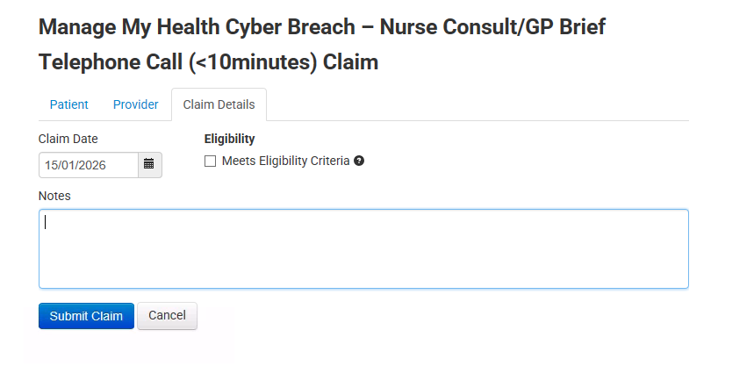
- 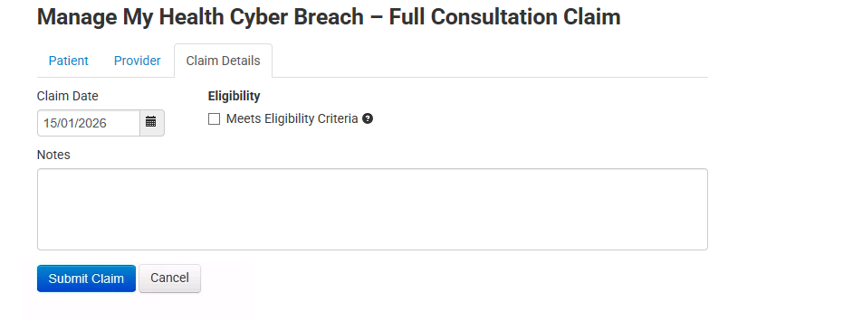
- What about other time spent on MMH?
Our legally sought advice is that practices should keep a note of costs being incurred in dealing with this matter. A practice's ability to get recompense from MMH may be limited by its specific contract with MMH. Contracts will differ from practice to practice. If a practice is on an unamended version of MMH's "Business Terms & Conditions" (19 June 2024 version), MMH has included clauses attempting to limit its liability to the practice to the value of Fees paid in the previous 12 months and attempting to exclude all liability for corruption or loss of data. There may be scope to argue that these limitation and exclusion of liability clauses do not apply or are legally unenforceable. We encourage practices to seek tailored legal advice on this point.
- If a patient comes in and wants details of the information that has been provided by MMH as being breached, is it eligible for a claim?
If an NP or GP deals with the claim, it can be recovered. If you need to call the patient back for a brief conversation, this too can be claimed.

HOW TO HELP MY PATIENT
Here are the MMH patient-facing FAQS: https://managemyhealth.co.nz/faqs-cyber-breach/
- A patient has asked if they were impacted. What should I do?
MMH has asked that they exclusively contact impacted patients. We have sought legal advice on this. Refer to the legal section below, but the recommendation is that you can generally contact patients on the list.
MMH states that for those that have an account, if a patients ring needing to know their status, please direct them to log into MMH.
Here is a script you could use to proactively email your patients.
Patients can also contact MMH directly via info@managemyhealth.co.nz or the 0800 helpline on 0800 747 778. The 0800 number will not be able to share any breached documents, but they will be able to provide other support pathways (see below).
- anymore/can’t see if they are impacted?
They should wait until MMH gets in touch.
- Is there a risk sharing the status with a patient?
As we have learnt with this slowly and every-changing management of the situation, information may be incomplete or evolving for example, lists of impacted individuals may change.
Therefore, there is a risk of misinformation and harm.
- What support can I recommend, whether they are impacted or not?
If a patient presents with anxiety, distress, or heightened risk, respond as you normally would; offer mental health or wellbeing support regardless of known impact status, including Access & Choice, BIS, or if available to the patient, the 0800 helpline.
- What should I do about vulnerable patients?
In MMH’s initial communications they asked practices to identify ‘vulnerable patients’ which meant withholding notification to those patients. MMH took further guidance from the Office of the Privacy Commissioner (OPC’s). The OPC’s view is that it would be best if notification is conducted with the appropriate support provided, rather than notification being withheld.

- Should I revise my ‘vulnerable patient’ list?
Yes, please. If you’d rather a patient was notified sooner and by MMH, please send a new list to MMH; resubmit NHIs for patients where it is ‘absolutely necessary’ that this information is withheld from them.

- Who is the 0800 number for/can we share it with anyone?
Yes, 20 January, the 0800 number line is open to all for support.
It is run by Whakarongarau.
Patients will get an email like this to contact the number. This is what the pathway looks like, MMH 0800 supports pathway.
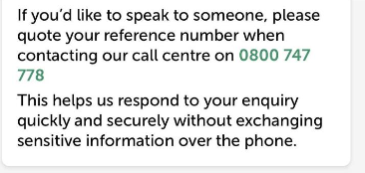
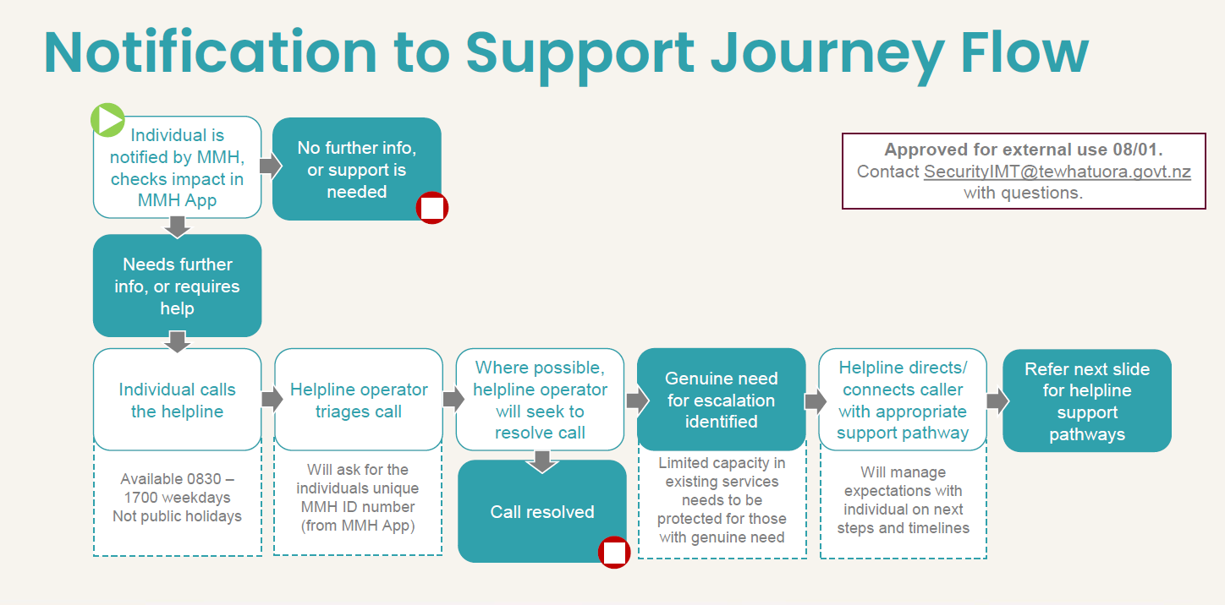

LEGAL ADVICE SECTION

MMH has asked that they exclusively contact impacted patients. We have sought legal advice on this. The recommendation is that you can generally contact patients on the list.
Review the legal advice here.

- Should I Notify insurers?
Yes. Practices should consider whether they hold any technology, cyber or other insurance that might cover the costs they are incurring in responding and, if so, notify their insurers.
What recourse do we have against Manage My Health?
Practices should keep a note of costs being incurred in dealing with this matter. A practice's ability to get recompense from MMH may be limited by its specific contract with MMH. Contracts will differ from practice to practice. If a practice is on an unamended version of MMH's "Business Terms & Conditions" (19 June 2024 version), MMH has included clauses attempting to limit its liability to the practice to the value of Fees paid in the previous 12 months and attempting to exclude all liability for corruption or loss of data. There may be scope to argue that these limitation and exclusion of liability clauses do not apply or are legally unenforceable. We encourage practices to seek tailored legal advice on this point.
- Can I end my contract with MMH?
This will depend upon the terms of the practice's specific contract with MMH. But a practice on an unamended version of MMH's "Business Terms & Conditions" (19 June 2024 version) can immediately terminate if MMH breaches a material obligation under the Business Terms & Conditions and that breach is not capable of being remedied. The advice we have obtained is that the data breach is likely to constitute a material breach of clause 10.1 (failure to have adequate security measures to protect the practice's information from unauthorised access) which cannot be remedied, giving the practice a right to terminate. Notice of termination can be emailed to the MMH email address specified in their MMH Proposal (or any email address for notices that MMH has subsequently notified the practice of). MMH must provide the practice with a copy of all Practice Data it stores in a common electronic form if the practice requests this within 1 month of the termination (provided the practice pays MMH's reasonable costs of providing the copy).
- Can we ask Manage My Health to delete our patients' accounts?
The FAQs on MMH's website include information about how a patient can delete their Manage My Health Account. Practices can refer patients wanting to close their MMH account to the relevant FAQ (FAQ #22) here.
MMH has been refusing requests from practices that MMH bulk-delete their patients' accounts. MMH's view is that account closures must instead be initiated by the patient. There is some debate about MMH's position under privacy law but currently if a practice moves away from MMH it should ask its patients to each delete their MMH accounts.
- What other practical steps should we be taking at this time?
Practice good record keeping and internal reporting. Practices should maintain records of practice-patient communications on this matter, including patents' requests for copies of health information held by the practice and any complaints, as well as any new processes adopted to respond to patient concerns. These records will help facilitate any subsequent engagement with the OPC which may arise, including in the event of a privacy-related complaint against the practice.

USING MMH, CLOSING ACCOUNTS SECTION
- Is Manage My Health safe to use?
No other part of the application was affected, and MMH says they have fixed and tested the My Health Documents module. External cybersecurity experts have now also confirmed that the application is safe and secure and can continue to be used. The PMS and the connection between the PMS and Manage My Health are safe and secure and were not breached by the hackers.
- Is it best for a practice or patient to close an account?
MMH's view is that account closures must be initiated by the patient. There is some debate about MMH's position under privacy law but currently if a practice moves away from MMH it should ask its patients to each delete their MMH accounts.
- How do I close an account?
For patients, instructions here or the following steps.
To delete your Manage My Health account, follow these steps:
1. Log in to your Manage My Health account.
2. Go to your Profile section.
3. Select “Close Account” from the menu options.
It takes 72 hours to delete data off the platform (see below).
For practices to delete accounts, refer to Karen’s Tips, printable PDF here or view screenshots below. We advise you get consent from patients before closing their account.
A query we are looking at is If the account is suspended by the practice how does that impact what data can be seen and for how long?

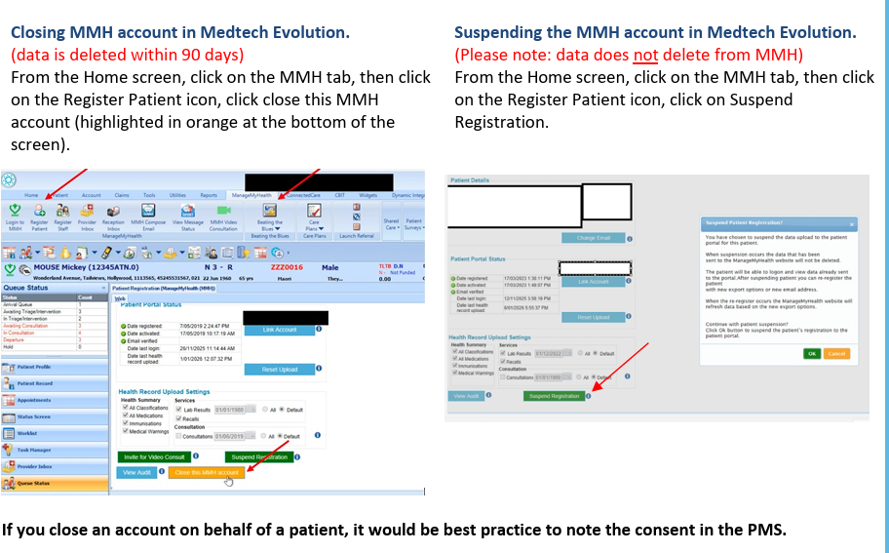Updated Feb:
1. If an individual customer/patient closes their account, the data is deleted off the app/platform at 72 hours. They nor their practice will be able to access their data after 72 hours. Yes, correct.
2. If an individual customer/patient closes their account, the account closes after 72 hours, but the data is only deleted after 90 days. No, the data is deleted after 72 hours of grace period, in case they decide not to close their account.
3. If a practice closes the account on behalf of a patient, the account is deleted after 72 hours (ie after 72 hours the patient cannot go onto the app) and the data is deleted at 72 hours. Yes, correct.
4. If a practice closes the account on behalf of a patient, the account and data are deleted at 90 days. No, it is deleted after 72 hours.
- What happens to health information after closing an account?
Once an account is permanently closed, previously stored health records will be deleted from the portal and become permanently inaccessible, and they cannot be recovered. Portal records become permanently inaccessible once an account is closed.
- What if I suspend an account?
If you suspend the account, all the data stays there, however no new data is added to the account.
If you can only suspend an account, it means you haven’t done the update that was sent out late last year (2025) which gave practices the ability to close accounts on behalf of the patient. This was designed primarily for patients that have incorrect child sign-ups, deceased patients or self-registration conflicts. Some practices didn’t do this update and are now struggling to get MMH to assist with getting the update done.

GETTING IN TOUCH WITH MMH
- Is it worth trying to contact them?
Yes, we have found that once your ticket comes up and you have a service person at MMH, they will respond to your questions. It may take a day or two, but it will help having direct contact.
- What’s the best email to use?
practicesupport@managemyhealth.co.nz
WHAT IS WELLSOUTH DOING?
- All we can!! We attend daily meetings with other PHOs, MMH, HNZ and GPNZ, asking questions and hearing updates.
- We present updates to practices with a drop-in webinar followed by an email with updates.
- We have set up a page here https://wellsouth.nz/provider-access/mmh-cyber-breach-practice-resources that we update.
- We have sought legal advice.
- We have been in touch with MMH directly to get answers to specific questions.
- We have shared tips, FAQs, and other information to support decision-making.
- We have set up the claim pathway.

